Cenozoic alkaline volcanism in central Madagascar in the context of intracontinental rifting

Rufer Daniel, Schreurs Guido, Berger Alfons, Gnos Edwin & Villa Igor

Insitute of Geological Sciences, University of Berne, Switzerland
daniel.rufer@geo.unibe.ch

The youngest plate reorganization in the Indian Ocean started ~34 Ma ago with the opening of the Red Sea and the formation of the East African Rift, and since the mid Miocene, Madagascar has come under an extensional tectonic regime (Bertil & Regnoult, 1998).
Multiple indications for this east-west extension can be observed on the central highlands of the island: a high seismic activity with normal fault focal mechanisms and distribution preferentially along pre-existing tectonic trends (Bertil & Regnoult, 1998); gravimetric and seismic data indicating a thinned crust and lithosphere, related to asthenospheric upwelling (Rakotondraompiana et al. 1999); extensional structures (e.g. grabens and basins, Piqué et al. 1999) as well as extensive Tertiary to Quaternary volcanism. Such young volcanic fields can be found in the central highlands (Lac Itasy and Ankaratra) as well as in the north of the island (Nosy Be, Massif d’Ambre and Tsaratanana).
The focus of our study lies on the volcanic province of the central highlands (Figure 1) with the goal of better understanding the younger tectonic history of central Madagascar and to gain insight into the early stages of intracontinental rifting. A detailed petrological and geochemical study of the alkaline volcanic rock sequence of these young fields should yield information about its source, magmatic processes and mantle evolution in a region where asthenospheric upwelling under an old continental lithosphere takes place. Dating of the volcanic deposits will allow to establish a temporal framework for these processes, permitting us to link the volcanic activity with the young tectonic history.
Existing age data suggest two main volcanic episodes in the upper Miocene (11-9 Ma) and the Quaternary - both of which seem to correlate between the volcanic provinces of the central highlands and the north of the island.
The age record for the central highlands is still especially sparse and it is unclear whether we deal with a continuous volcanic activity or discrete stages.
The larger Ankaratra field (Figure 1) can be subdivided into an assumed Neogene part, consisting mainly of basaltic and phonolitic flows and tuffs and less abundant trachytic plugs, and a Quaternary part, which includes mainly basanitic and tephritic flows and tuffs with a noted absence of trachytic material. The smaller Lac Itasy field (Figure 1) is dominated by basanitic to tephritic material that forms small flows and tuff cones, larger phonolitic flows and trachytic domes. This field is of as yet unknown age, but probably not older than Quaternary.
First geochemical data show an alkaline volcanism of peraluminous type for both regions. The Quaternary Lac Itasy field yields comparable patterns to the Neogene part of Ankaratra with decreasing Cr, Ni, MgO and TiO₂ contents and increasing Al₂O₃ and incompatible elements vs. SiO₂ concentration. This is indicative of fractionation of Cpx, Fsp and Ti-magnetites.
In comparison, the Quaternary Ankaratra rocks show different patterns in comparison with the neighbouring Neogene Ankaratra volcanic rocks as well as the Quaternary Lac Itasy volcanics, pointing to an influence by primitive material and an increasing degree of melt production. This is reflected by higher Ni and Cr concentrations as well as increasing CaO/TiO₂ and decreasing Al₂O₃ vs. SiO₂.
While the reasons for the chemical differences between the contemporaneous Lac Itasy and the Quaternary parts of the Ankaratra region remains to be investigated, these findings could corroborate the geophysical indications of an asthenospheric upwelling under the central highlands of Madagascar.

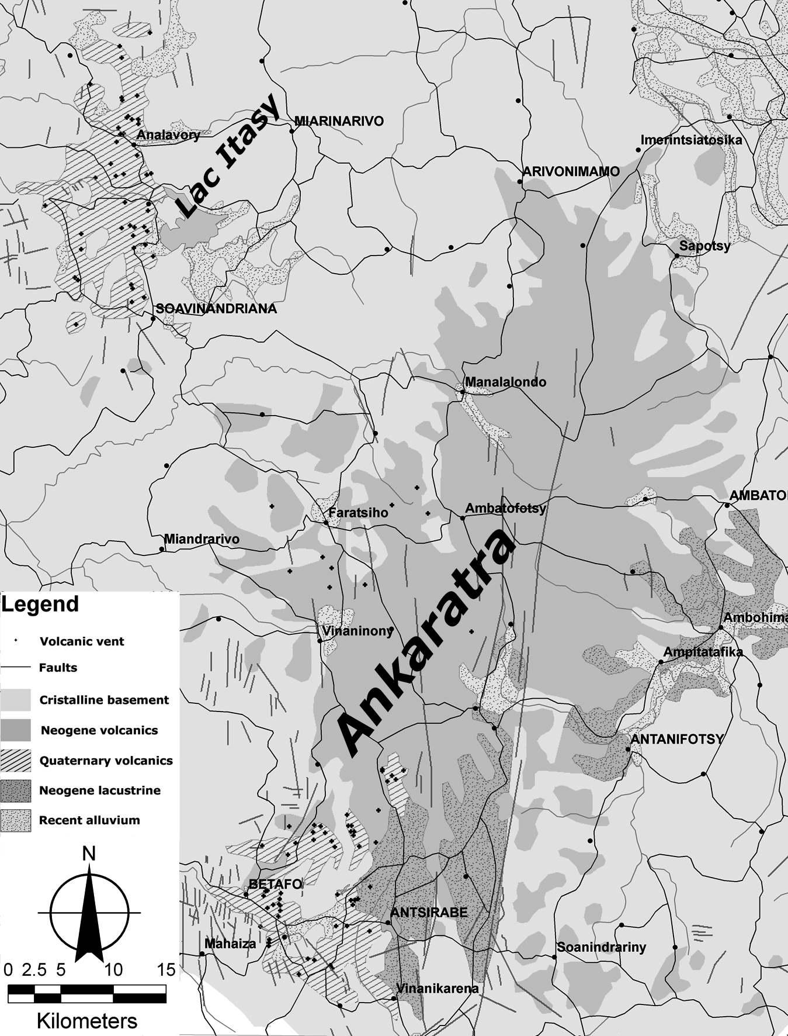 | 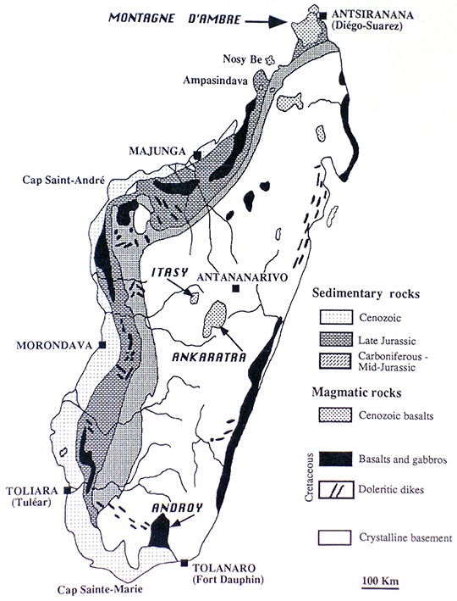  Figure 1. The volcanic fields of Lac Itasy and Ankaratra in the central highlands of Madagascar.

REFERENCES
Bertil, D. & Regnoult, J.M. (1998): Seismotectonics of Madagascar. Tectonophysics Vol. 294, 57-74.
Rakotondraompiana S.A. et al. (1999): Modèle de lithosphere pour l’île de Madagascar (océan Indien occidental): nouvelle interprétation des données gravimétriques. Journal of African Earth Sciences Vol. 28 No. 4, 961-973.
Piqué A. et al. (1999): L’extension à Madagascar du Néogene à l’Actuel: arguments structuraux et géophysiques. Journal of African Earth Sciences Vol. 28 No. 4, 975-983.

