Garnet in mafic rocks of Ile de Groix (France) and its relationship to the tectonic units and whole rock composition

El Korh Afifé*, Schmidt Susanne Th.*, Potel Sébastien** and Ballèvre Michel***

* Département de Minéralogie, Université de Genève, Switzerland
**Geologisch-Paläontologisches Institut, Frankfurt am Main, Germany
***Université de Rennes, France

The high-pressure rocks of the Ile de Groix, consisting of 80% metapelites and 20% metabasites, belong to a submerged Hercynian HP/LT metamorphic belt, which crops out on the southern coast of Brittany. Recent studies focused on the metamorphic evolution of the micaschists, and the dating and correlation of the different metamorphic and tectonic events (Bosse et al., 2002; Bosse et al., 2005). Two metamorphic phases have been recognized: a blueschist facies metamorphism (M1, around 360 Ma) related to subduction, and a greenschist facies overprint (M2, around 350 Ma). A "garnet isograd" defined by Carpenter (1976) has been reinterpreted by Bosse et al. (2002) as a ductile thrust active during the exhumation process dividing the island into the Upper Unit or garnet-bearing and high-pressure zone in the eastern part of the island (8-9 kbars; 400 ± 50°C), and the Lower Unit or garnet-absent and lower pressure zone in the West (6.5-8 kbars; <400°C).

This study focuses on the chemical characteristics of garnet, its relationship to the ductile thrust and the mineralogical and chemical composition of the metabasites. Based on the mineralogical assemblages, the metabasites were divided into eclogites or omphacite-bearing blueschists, blueschists, sometimes partially retromorphosed, and greenschists. Eclogites and blueschists are frequent in the Upper Unit, whereas the Lower Unit is dominated by greenschists. In addition, the metabasites of both tectonic units can also be divided into two groups, depending on their structure: massive and banded rocks, both present in the Upper and Lower Units.

Garnet is very abundant in the Upper Unit. Its size varies from 1 to 10 mm. Garnet is rare in the Lower Unit with a size varying from 1 to 3 mm. Garnet from eclogites and blueschists is generally euhedral and relatively fresh, contrary to garnet from blueschists strongly retromorphosed and greenschists. Garnet occurring in massive and banded metabasites was analyzed by electron microprobe analysis in each metamorphic facies. Garnet in banded rocks possesses few inclusions and shows a typical bell-shaped zonation pattern with a Mn-rich and Fe-poor core. Garnet in massive rocks shows many inclusions and displays two types of zoning profiles: a bell-shaped pattern with a less Mn-rich core and a flat pattern, without compositional change from rim to core. Rims of garnets from the banded metabasites are generally richer in almandine and spessartine than those of garnets from the massive metabasites (El Korh et al., 2004, 2005). All these observations indicate that the different characteristics of garnets in the metabasites are mainly determined by the nature of the protholith. The ductile thrust does not control the neither the occurrence of garnet, its composition or the chemical zonation of garnet: the same types of profile exists in both tectonic units and the protolith is responsible for the composition and the type of profile of the garnet.

XRF whole rock and LA-ICP-MS trace element analyses of several metabasites indicate that the massive rocks are derived from tholeiitic basalts of MORB type or within-plate type basalts (Figure 1). The spider diagrams do not support an arc origin. LILE and LREE are enriched in all the metabasites compared to N-MORB. HFSE are also enriched, but depleted compared to LILE. This could be caused by a continental influence but could also be caused by an hydrothermal alteration on the ocean floor before HP/LT metamorphism or by the circulation of fluids during the metamorphism.The banded rocks are more enriched in LILE and their Mg content is gnerally lower that that of the tholeiitic rocks. This as well as their structure, suggest that they may be of volcano-sedimentary origin.

P-T conditions of the metamorphic peak in the Upper Unit were calculated with THERIAK-DOMINO to be at 1.5–2.5 GPa, 500–600°C for an eclogite (GR 29, Figure 2), 1.65–2.35 GPa, 460–525°C for a massive blueschist (GR 02), and 1.05-1.45 GPa, 475-570°C for a banded blueschist partially retromorphosed (GR 03). In the Lower Unit, P-T conditions were estimated to be 1.0–1.5 GPa, 400–550°C for a massive blueschist weakly retromorphosed (GR 08c). These P-T conditions found for the metabasites are similar to the conditions determined by Bosse et al. (2002) for the metapelites (1.6-2.5 GPa, 500°C for the Upper Unit and 1.2-1.6 GPa, 450°C for the Lower Unit).

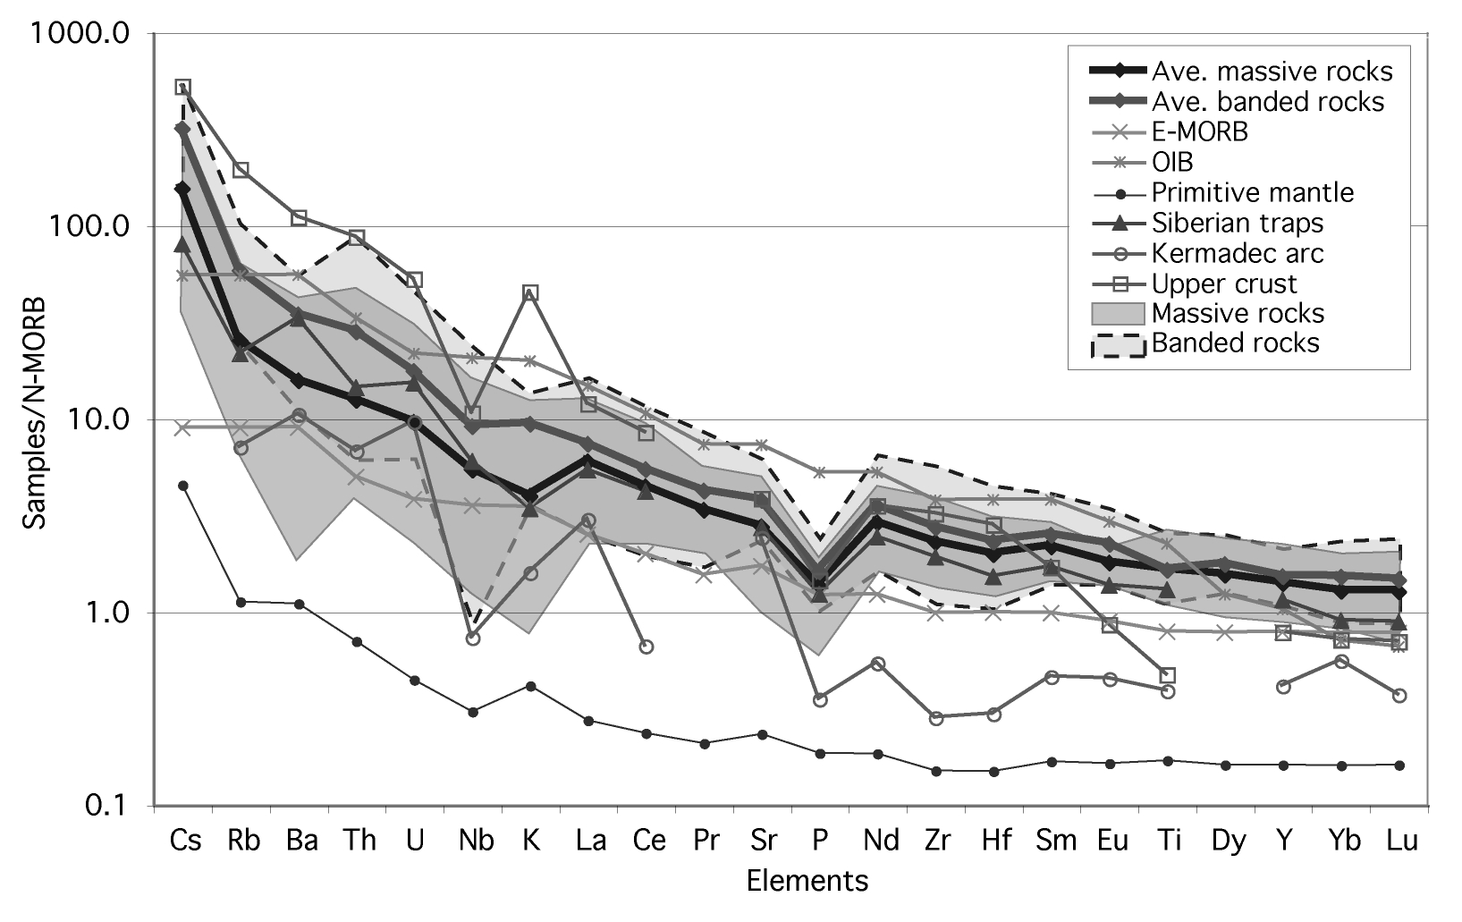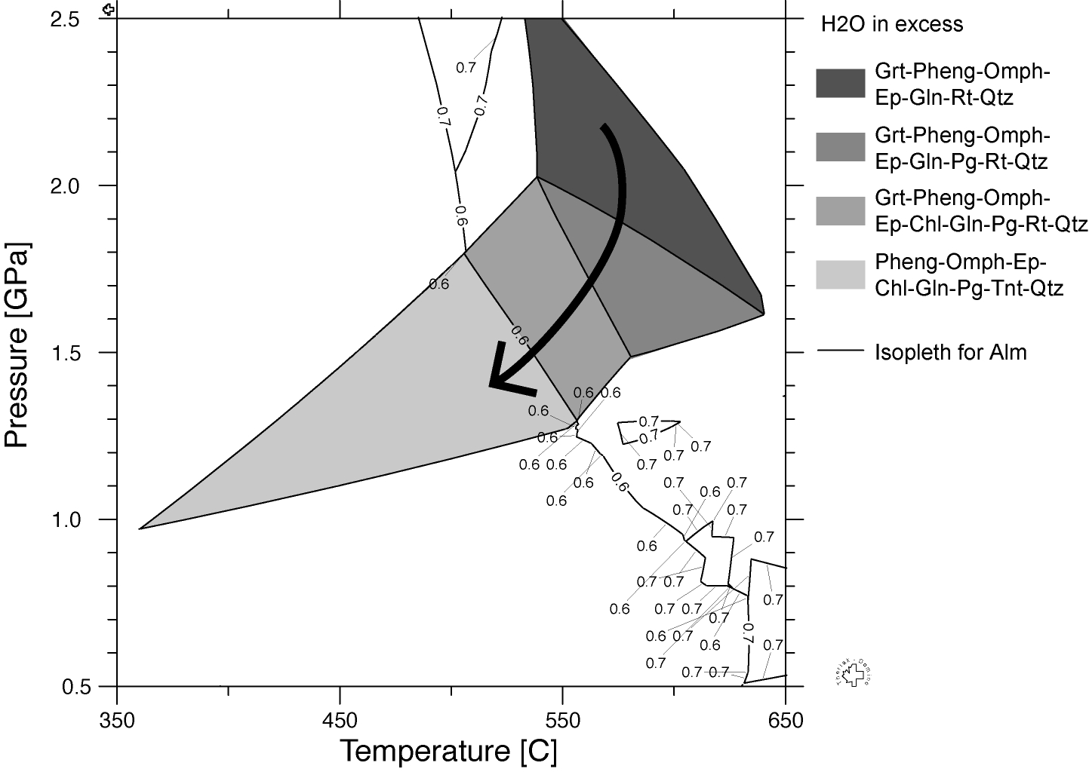

Figure 1. N-MORB-normalised (Sun & McDonough, 1989) trace spider diagram representing plots from the average values and fields of massive and banded rocks from the Ile de Groix compared to basalts from different tectonic settings.

Figure 2. P-T path of the eclogite GR 29 (Porh Giguéou) calculated with the software THERIAK-DOMINO. The stability field of the stable paragenesis at the peak of metamorphism (Grt-Pheng-Omph-Ep-Gln-Rt-Qtz) is represented in dark grey.

REFERENCES
Bosse, V., Feraud, G., Ballèvre, M., Peucat, J.J., Corsini, M. (2005): Rb-Sr and 40Ar/39Ar ages in blueschists from the Ile de Groix (Armorican Massif, France): Implications for closure mechanisms in isotopic systems. Chemical Geology, 220: 21-45.
Bosse, V., Ballèvre, M., Vidal, O. (2002): Ductile thrusting re-corded by the garnet isograd from blueschist-facies metapelites of the Ile de Groix, Armorican Massif, France, J. Petrology, 43(3): 485-510.
Carpenter, M.S.N. (1976): Petrogenetic study of the glaucophane schists and associated rocks from the Ile de Groix, Brittany, France, Ph.D. thesis, Oxford University: 271p.
El Korh A., Schmidt S. Th., Ballèvre M. (2004): Zonation of garnet in the high pressure mafic rocks of the Ile de Groix, Britanny, France: First results. 2nd Swiss Geoscience Meeting, Lausanne, November 19-20, abstracts, vol. 2: 129-130.
El Korh, A., Schmidt, S. Th., Ballèvre, M. (2005): Relationships between garnets and whole rock composition in the high-pressure metabasites of the Ile de Groix, Brittany, France. 3rd Swiss Geoscience Meeting, Zürich, November 18-19, Abstracts: 367-368.

